TABLE OF CONTENTS

AGENDA 2
2022 AGM MINUTES 3
MINISTRY REPORTS 5
Reverend Dave 5
Reverend Barbara 7
BOARD REPORTS 8
Board Chair 8
Legacy Fund 9
CHRISTIAN DEVELOPMENT 10
Messy Church 11
CONGREGATIONAL LIFE 12
Circles of Care 12
MINISTRY & PERSONNEL (M&P) 13
OUTREACH 15
Affirm 15
Central Alberta Foodgrains Project 16
Friends Of Guatemala - FRoG 17
Healing Pathway 18
Lacombe & District Volunteer Link 19
Lacombe Food Bank 20
Living Into Right Relations 21
PROPERTY 22
UCW 1 23
UCW 2 24
WORSHIP TEAM 25
Audio Visual Technology at St. Andrew’s 26
CHURCH STATISTICS FOR 2022 27

AGENDA
ANNUAL CONGREGATIONAL MEETING
Sunday, January 29, 2023
(Please submit all motions for this meeting in writing)
- Opening Prayer
- Welcome
- Voting
  - Motion: All present, member and adherents included, have the right to vote
- Agenda: additions, approval
- Minutes: Approval of the Congregational Meeting minutes of March 27, 2022
- Business Arising out of the minutes of March 27, 2022.
- Review of the 2022 Annual Reports: printed and oral
  - Motion to receive all reports for information.
- New Business
  - 2023 Budget
  - Legacy Fund Recommendations

- Based on a recommendation from the Outreach Team, the 2023 Legacy Fund disbursement in the amount of $1,565.00 for the Community Portion, be provided to The Broom Tree Foundation in Lacombe. Moved by Doug Maas

- Based on a recommendation from the Outreach Team, the 2023 Legacy Fund disbursement in the amount of $1,565.00 for the World At Large Portion be provided to A Better World of Lacombe for its world projects. Moved by Doug Maas

- Motion(s) to approve congregation portion.

- Elections
  - Presentations of teams and vacancies
  - Nominations from the floor
  - Election of Board Chairperson for 2023 (1-year)
  - Chinook Winds Regional Representative (1-year)
  - Trustees for 2023 (Board Chair, Chinook Winds Regional Representative, Finance Chair, Property Chair (1-year)
- Appointment of Independent Internal Examiner
- For Information:
  - Volunteer Link Representative: Tom Crozier
  - Members of the M&P Team (appointed by the Board) Barry Brouwer, Jim Dixon, Karen Yakimishyn, Sandra Smith-Bernatsky and Ron Gish
- Motion to destroy ballots (if needed)
- Announcements and Courtesies:
- Closing prayer
- Adjournment

2022 AGM MINUTES

Annual Congregational Meeting Minutes
St. Andrew’s United Church
Sunday, March 27, 2022

St. Andrew’s United Church Annual Congregational Meeting was held in the sanctuary on Sunday, March 27, 2022 following a potluck luncheon. There were 38 in attendance. See list attached.
Lawrence Hrycan called the meeting to order at 12:30 PM. Candles were lit sending thoughts and prayers to the Ukraine. Jana Figursky was recording secretary.
- Opening Prayer – Reverend Barbara Lieurance

- Welcome – Lawrence Hrycan, Lawrence introduced Shannon Epp and Jana Figursky as new staff members. Linda Hueppelsheuser and Tilly Meyer send their regrets. Despite the pandemic the St. Andrew’s Board has met more often than ever to share communication.

- Voting
  - Motion: All present, member and adherents included, have the right to vote except on specific motions as indicated beforehand. Sandy Douglas, Madeline Hendrickson. Carried.

- Agenda - additions, approval. Motion to approve the Annual Congregational Meeting Agenda for March 27, 2022. Ko Bruning, Jane Wilkinson. Carried.

- Minutes – Motion to accept the Congregational Meeting minutes of January 26, 2020. None for 2021. Sandy Douglas, Bryant Burnard. Carried.

- Business Arising out of the minutes of January 26, 2020. No arising business noted.

- Review of the 2021 Annual Reports: printed and oral
  - Motion to receive all reports for information. Ron Gish, Sarina King. Carried.

- New Business
  - 2022 Budget. Hans Haefliger and Shannon Epp reviewed the 2021 finances and presented the 2022 budget. For 2021, our total income was $273,064.37, our total expenses were $258,854.77, with a surplus of roughly $15,000.00 thanks mostly to the grant income. We are running a deficit of $36000.00. Suggestions were made that we organize a stewardship program to deal with our deficit in order to let people know we need more money. The financials will continue to go into the monthly newsletters. We might also think of advertising to people who don’t attend church, but listen online as some donations have come from our online audience. Hans thanked Linda and Shannon for their hard work. Motion to accept the 2022 budget. Bryant Burnard, Sandy Douglas. Carried
  - The Affirm Team as a voting member of the Board – The congregation feels it is important to have an Affirm member on the board so that they don’t become invisible or ineffective. This will ensure that others continue to have a voice and representation in our church body.
Motion: Moved by Doug Maas, seconded by Shelley-May Lloyd, that the Church Board include a member of the Affirm Team (Brie Schmidt) as a voting member. Carried.

- Elections
  - Presentations of teams and vacancies
  - Nominations from the floor
  - Election of Outreach and Congregational Life persons to the Church Board (3-year term) Doug Maas will serve for Outreach. Lynn Millar will be the board representative for Congregational Life, Sarina King has volunteered to help Lynn.
  - Election of Board Chairperson for 2022 (1-year) Bryant Burnard nominated Monique Vermegen. Monique Vermegen agreed to let her name stand and was elected.
  - Chinook Winds Regional Representative (1-year) Lawrence Hrycan will continue in this position.
  - Trustees for 2022 (Board Chair, Chinook Winds Regional Representative, Finance Chair, Property Chair (1-year)
  - Appointment of Independent Internal Examiner, Motion to have Sandra Radau as the Independent Examiner for 2022. Bryant Burnard, Madeline Hendrickson. Carried.

- For Information:
  - Volunteer Link Representative – Doug Maas – one year remaining
  - Members of the M&P Team (appointed by the Board) Barry Brouwer (Chair), Jim Dixon, Karen Yakimishyn, Sandra Smith-Bernatsky.
  - Camp Kasota Rep(s) – Madeline Hendrickson

- Announcements and Courtesies – Special thank you to Tilly Meyer who is going off the board, and to Doug Maas who will continue. Special thank you also to Karen Yakimishyn for her service as Transition leader and as Past Chair. Bryant Burnard thanked Lawrence Hrycan for his years of service.

- Closing Prayer – Reverend Dave closed in prayer.

- Adjournment – Meeting adjourned at 1:35 PM

MINISTRY REPORTS

Reverend Dave

This is now my second annual report! Often, the second year of ministry is a difficult one (one of my early supervisors said ‘the first year you can do nothing wrong, the second year you can do nothing right, and the third year you can start ministry’). I am pleased to say that while several challenges have arisen for us this past year, things seem to be going very well, and I remain very grateful to be here at St. Andrew’s.
Let me start with my gratitude list. I feel incredibly privileged to work in the staff team of which I am a part here at this church. Barbara and Jana, with whom I work most closely, are not only gifted and skilled, but are just outstanding, faithful human beings. I think we are privileged to have Nicole and Leanne to make music in our hearts and souls, and Jill, Shannon, Terry, Diane, Lee and now Dale – who may rarely be seen – uphold and support all our work in important ways. What a great crew with which to work! Committee/team chairs and members, board members, people who have jumped in to lead and serve in various projects, and those who simply show up and participate – you all make this a very strong church, important not only to us but also to this whole community! Thank you!
We continue to live and “do church” in the midst of a weird world. I remember reading in the church history book a quick note that after an outbreak of polio in Lacombe, it took the Sunday school ten years to recover. And that was in a time of rising church participation! We live in a time like that, compounded by trends of declining church participation. Something like the pandemic has, I think, more of an effect on us than we might realize. So this past year has been a year of re-starting programs, but often with lower attendance: Messy Church, men’s breakfast, congregational dinners and events, coffee time and even Sunday worship. Some programs have entered an experimentation phase, where we recognize that the old programs aren’t working, so we try new things – Sunday school is a good example of that.
Since I arrived during the pandemic shut-down, I have no memory or image of St. Andrew’s before the pandemic, no “good old days” with which to compare the present. For those that do, I encourage you NOT to worry, but rather to be curious. We do live in a time of great challenge, but there is also great strength here, not all of which is visible Sunday by Sunday. I encourage you to look for God’s blessing and listen for God’s call. Times of difficulty are also times of blessing.
Here are some of the challenges we face:
- Having been through some conflict over the past few years, I think we face the challenge of reconciliation – forgiving one another, rebuilding trust, healing. I do not expect that we need to revisit decisions that have been made! But we do need to address the hurt that remains in at least a significant part of the congregation. Look for a process to do this to be rolled out, likely in the first half of this year. (Continued on next page…)
- In some ways, we have found some stability since I have arrived here, and that has allowed some leaders who have carried various responsibilities in this church over the years to step back, rest, or find new interests. But as we discovered this past October, this is also a pretty low-energy time. People are reluctant (and this applies to nearly every organization I know) to take on longer-term responsibilities and leadership. As I write this, I expect that there will be some vacancies in key teams and on the board, as we head into the annual meeting. This leadership transition is a challenge for us. On the one hand, we don’t want to twist any arms! When we have “reluctant leaders” it’s not good either for the leader or for the church! On the other hand, the structures of this church are what give it its strength, and they make the programs and projects possible. So, again being curious rather than anxious: is the church as institution changing form? What might it become? Will new leaders come forth, and what changes might they bring? We may face some short-term discomfort, because I think most of us on the board are clear that we’d rather leave a position vacant than push someone into it.

- Looking at our mission statement this past October, I became more aware that one of our core practices – teaching – is something I at least have not really engaged yet. Our marvellous CD team (as well as Worship) is working on how to do spiritual formation with children and families, but how about the congregation as a whole? How do we teach, learn, practice our faith in this new world? This will be something I’ll be working on this year.
I do want to be clear that we’re not just experiencing challenges here. There is much to celebrate, also! One thing to celebrate is the open, creative way that this congregation and its leaders are embracing the challenges – it’s genuinely exciting to be part of this! The CD team is trying new ideas, the board is learning to practice spiritual discernment (as several of us take a course offered by LeaderShift in BC), and our current worship team is laying the foundation for future change. This year sees a resurgence of our Living into Right Relations team, and Affirm, and we look for formation of a worship band and a team looking at environment.
So I conclude with gratitude again. I feel very, very privileged to be here at St. Andrew’s. Here, it feels like we are facing the challenges not with anxiety or desperation, but with creativity, and hope, and trust. Okay… maybe there’s a little bit of all those things, but at this church I do not come to work feeling overwhelmed. I come with gratitude, and excitement. This is the adventure I want to be on, and you are the ones I want to travel with. Thanks be to God!
Dave

MINISTRY REPORTS

Reverend Barbara

Have you ever wondered what gratitude might look like? Maybe wearing a colourful coat? Or sound like? Maybe singing a melody? Can you tell I am delighted to work with children and their families exploring together all kinds of wondering questions?
Well, no matter how you may imagine gratitude, it is alive and well in so many ways at St. Andrew’s. Every Sunday morning, Dave starts with expressing gratitude, gratitude that picks up momentum all through the week inside and outside our building.
So, caught in the flow of gratitude, it’s not surprising that I want to express a big thank you to my teammates, Jana and Dave, whose dedication, encouragement, and sense of humour make it easy to “listen to God together” (Lacy Finn Borgo).
Thank you, also, to everyone else who lives, works and plays (to lift some words from a land acknowledgement) at the community of St. Andrew’s. You make this community of faith come alive!
This past year has been a year of profound change for me. After saying good-bye to the Erskine and Big Valley communities of faith at the end of June, I started to work more hours at St. Andrew’s community of faith AND to show up on Sunday mornings, something that I could not do prior to my change in pastoral relation.
Our Advent 2022 theme was “listening, paying attention”. I hope to listen to, to pay attention to, to connect with two groups in our community of faith we may not see on Sunday morning worship: place-bound seniors as well as children and their families, sharing wondering questions with the ones who just started life and the ones who are looking towards the end of life.
You may have noticed that I often use the expression ‘community of faith’, which can be a mouthful. I love saying it, for it speaks to who we are, people coming together awake to the more of life. What a blessing, what a gift!
I trust that in the challenges and joys of our community of faith, all of us listening to God together, we will find ‘grace upon grace’.
With deep gratitude for our shared ministry,
Barbara

BOARD REPORTS

Board Chair

First let me say that it has been an honor and a pleasure to serve St. Andrew’s as board Chair this past year. I have had the privilege to work with a talented and generous group of people and am so grateful for all of them, my fellow board members, as well as our dedicated ministers and staff.
As I sit down to write this report, I have an old children’s song running through my head.
I am the church
You are the church
Yes! We’re the church together.
All who follow Jesus
All around the world.
Yes! We’re the church together.
Over the course of my time here, I've seen how much work goes into making this church what it is. I have been aware that St Andrew’s is blessed with a great number of hardworking volunteers, but I am continually impressed at how much energy and enthusiasm these teams and individuals have toward caring for this community of faith. I would like to thank all who have shared their time and talents here at St. Andrew’s.
A regular item on the agenda this year has been reflection time where we are exploring new leadership strategies. Some people on our leadership team have been involved in a course entitled "Moving from Decision Making to Discernment". According to Ruth Haley Barton, discernment is an ever-increasing capacity to "see" the work of God in the midst of the human situation, so that we can align ourselves with whatever God is doing. The board has been moving in the direction of prayerful and intentional discernment and while it is a new and, for many of us, unfamiliar practice, we are excited to embark on this process. It is our collective desire, as a board, to become more intent to the leading of the Spirit.
These past couple of years have been difficult as we all tried to navigate the pandemic but now, since we are permitted to gather again, I'd like to invite you to reengage with St. Andrew's. If you are eager and enthusiastic to join in and share your passion with this church there are so many opportunities to get involved and I would encourage you to do it.
Yes! We’re the church, together.
Respectfully submitted,
Monique Vermegen

BOARD REPORTS

Legacy Fund

The Legacy Fund (Fund) of St. Andrew's acts as a quasi-endowment fund.

One-half of any new donations in a calendar year and all interest paid on the investments in the Fund that year, are eligible for distribution.

Forty per cent are available for distribution to our Community of Faith for items of a non-administrative nature such as new hymn books, new cushions for our pews, and an updated directory.

Thirty per cent are for Community charities and thirty per cent for the World At Large charities.

All disbursements are approved by the Community of Faith at the Annual General Meeting.

The balance of The Legacy Fund as of December 31, 2022 is $73,155.30.

It is the intention of the Fund committee in 2023 to do more promotion of the Fund in order to create more awareness and grow it.

Current team members are Ko Bruning and Doug Maas. We could use more help on the Team, so please contact Doug Maas at 403-318-5733 to discuss.

Submitted by,
Doug Maas - Chair

CHRISTIAN DEVELOPMENT

The Christian Development Team is an energetic and enthusiastic team whose purpose is to support and nurture faith-based learning for young and old. We support a variety of programs and are always looking for ways to expand our faith focus within the church.
Members: Teri Lynn Amundson, Alida Burnard, Dustin Butterfield, Annerie Dunnewind, Sandy Douglas, Norm Start, Lawrence Hyrcan, Claudine Bruning
Christian development supports adult learning initiatives provided by the minister, confirmation classes, Sunday School, Nursery, VBS, Youth group, Messy Church, Kasota East Camp, activities for families with young children and the church library.
Our Sunday School Program went through some revamping this year as well. After experimenting with revolving Sundays, we have returned to regular Sunday programming, led by Minister Barbara Lieurance. She brings energy and enthusiasm for faith and learning that will definitely be caught by our youngsters.
For our fourth annual Easter Egg Hunt, we were able to return to the church. Children enjoyed searching for eggs both inside and out and we added a few Easter themed games this year.
Faith at Home kits are still available for our church families. These kits guide us through Lent, Pentecost, Advent etc. These kits are complete with instructions/directions and activities as well as scripture readings and much more.
The church garage sale and Kasota Flower Sale were once again held in conjunction with each other and were a huge success. We are lucky to have the support of so many members who make these two events happen each year. We will miss the leadership of Madelaine Hendrickson, who passed this summer, as Kasota was near and dear to her heart.
We finished the year with a Christmas Storywalk. It was a beautiful evening, hosted at the Dunnewind Farm, where small groups were able to hear the story told from different perspectives. Support from various other groups in the church helped to make this event so magical.
We are blessed at St. Andrew’s to have this dedicated group of volunteers who strive to make the St. Andrew’s experience welcoming, enlightening, and open. If any of these areas are of interest to you and you would like more information or to volunteer, please contact the C.D. team or the church office.

CHRISTIAN DEVELOPMENT

Messy Church

Starting in May of 2022, the team was once again able to continue with the Messy Church program on the first Friday of the month. 2023 sees the beginning of our 10th year.

The themes in 2022 were as follows:

May Messy Camping
September Journey with Friends
October Gratitude - Included congregational members for supper
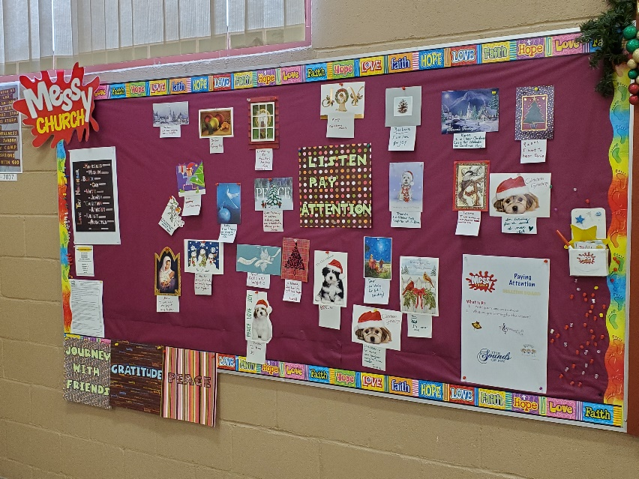
November Peace
December Listening and Paying Attention
December Christmas Eve
The December Messy Church was the 68th Messy Church offering since the program began in October 2013. Messy Christmas Eve services have been held for the past 5 years.

As many activities do at St. Andrew’s, Messy Church relies heavily on volunteers. Each year, in addition to many adult volunteers, 15 to 22 youth from St. Andrew’s and the community contribute their time in making this prayer and gathering time successful.
Families who participate have told us that they appreciate the youth involvement with their children.
This ministry runs from 5 to 7 p.m. the first Friday of each month. The participants are greeted and welcomed at the door, directed to the prayer station and the bulletin board and then on to other activities. From 5 to 6 p.m. everyone becomes involved with arts, crafts, and activities geared towards the monthly theme. At 6 p.m. we all move into the Sanctuary where the minister or a facilitator tie everything together in a lesson. St. Andrew’s is blessed in that both Reverend Dave and Reverend Barbara take part in the service. Not all Messy Church programs have ministry personnel involved. We sing 2 or 3 songs, say grace, and then move back to the auditorium for a meal and fellowship.
Volunteers are always welcome, whether it be assisting with a craft, a story, a game, a song, or with the food in the kitchen. Including our food preparation planning individuals, there are currently 18 adults on the planning team and 15 youth who volunteer. Everyone is welcome to come and simply see what the buzz is all about. Feel free to come and take part in this monthly Messy Church program.

CONGREGATIONAL LIFE

Circles of Care

COFFEE FELLOWSHIP
Coffee time at St. Andrew's is a very well attended event every Sunday. It is a chance to gather and reconnect every week with friends and get to know newcomers. Congregational Life looks after the scheduling of people to do the coffee each week and there is a signup sheet near the kitchen windows. We encourage everyone in the congregation to sign up sometime to provide this service and if you need help just ask.

MILESTONE BIRTHDAYS AND ANNIVERSARIES
We like to acknowledge these special days with a cake or flowers and a card.
We rely on the congregation to let us know the dates and names of the people we wish to honour. Last year we celebrated the 90th birthdays of three people. Our team has in the past got together to make cards for special occasions and will continue to do so as it is a great fellowship time. Please let the office know of anyone who is ill, grieving, or needs some encouragement and we will send them a card.

We also celebrated Mother's Day with flowers and cake and on Father's Day we had cake. Hot chocolate was served to the community the night of Lacombe's "Light Up the Night".

Now that the Covid restrictions have been lifted we hope to see more people out to St. Andrew's. If you are interested in helping with any of the things Congregational Life does, please let us know.

Submitted by Lynn Millar

MINISTRY & PERSONNEL (M&P)

The M & P Team of St. Andrew’s is a team of trust and confidentiality that provides support, assessment of and consultation with all ministry personnel and non-ministry staff of the church. Comprised of individuals from the congregation appointed to 3-year terms, the team provides a liaison between and among the congregation and the ministers and other staff of St. Andrew’s. As an advisory body, the team makes recommendations to the church board on ministry and personnel matters. The M & P Team is represented in the Church Board.

Our membership for 2022 was: Karen Yakimishyn, Sandra Smith, Jim Dixon, Ron Gish, and Barry Brouwer.

Ministry Staff – Since last January, we welcomed Ron Gish to the team, representing Rev. Dave Holmes. At the May board meeting, the board approved our recommendation to increase Barbara’s hours from 8 hours/week to 14 hours/week (beginning July 1), after Barbara retired from her appointment with the Big Valley / Erskine pastoral charge. In addition to Pastoral Care, Barbara will also be focusing on spiritual formation for children and families as well as ministry with children, youth, and young adults.

Office Staff – Jana Figursky (Communications and Community Service Coordinator) and Shannon Epp (Bookkeeper) have now been with us for another year, and their support for the ministers and finance team is much appreciated.

Janitorial, Custodial & Grounds Keeping – Jill Hair continues to provide excellent care of our building, in the janitorial position. The security/custodial contract has been updated to replace Lee Heindal with Dale Chenger, working with Diane Hayduk. Lee was unable to continue his duties, and we are grateful for his years of dedicated service. The janitorial and security/custodial contracts remain unchanged for 2023. Thank you to Norm Start for volunteering to do groundskeeping, and to Hans Haefliger for maintaining the beautiful flowerbeds throughout the spring, summer, and fall. The snow removal contract with I Care Lawn Service (Terry Souveny), will continue in 2023.

(Continued on next page…)

Staff Liaison - Individual team members endeavor to maintain regular and open communication with individual members of the Church staff, and these liaisons include:

Team Member | Staff Position
Karen Yakimishyn | Communications and Community Service Coordinator – Jana Figursky,  and Shannon Epp (Bookkeeper)
Jim Dixon | Building Janitorial, Security/Custodial and Grounds Keeping Contractors
Ron Gish | Full-time Ministry Position – Rev. Dave Holmes
Sandra Smith | 35% Ministry Position – Rev. Barbara Lieurance
Sandra Smith | Worship (Choir Director & Pianist) Support – Leanne Oslund & Nicole Bartolay
Sandra Smith | Honorary Associate Minister – Rev. Bob Settle
Barry Brouwer | Ministry & Personnel Team Chair

Karen, Jim, and Ron will be staying on the team for 2023. Sandra Smith has been serving on this team since 2013, and I have served as chair since 2016. We are both hoping to retire from M & P in 2023.

Members of the Congregation wanting to comment regarding an individual staff member or position are encouraged to contact these Team Members.
Submitted by Barry Brouwer, Chair

OUTREACH

Affirm

Our Vision:
A church and community that embodies God’s unconditional love by welcoming all people, regardless of sexual orientation, gender identity, ethnicity, social circumstance, ability or age.

Our Mission:
Affirm St. Andrew's is a group of people passionate about human rights and equality, committed to providing support and leadership as we move towards our vision.

The work of St. Andrew’s Affirm team focuses on making sure that all who enter our church feel welcome and genuinely included in this community. It is important to our team that no person be marginalized for any reason. We dream of a diverse church where differences are celebrated and cherished. Every individual is important to our congregation, and all are valued and offered a sense of God’s unconditional love.

This year Affirm St. Andrew’s began to meet regularly again and welcomed three new members to our team!

On March 13, 2022, we hosted a PIE Day celebration. PIE Day is a way that we can remind ourselves of the commitment we have made to be Public, Intentional and Explicit in our welcome to everyone regardless of sexual orientation, gender identity, ethnicity, social circumstance, ability or age. Members of St. Andrew’s generously provided pies for the celebration and we were able to gather to share food and fellowship after the service for the first time since the beginning of the pandemic.
On November 20, 2022, we celebrated the 10th anniversary of the vote to become an Affirming ministry with a special service that focused on the journey of Being an Affirming Ministry as process that is constantly ongoing, rather than a destination that we can arrive at.
For 2023, we're working on plans for social events, ways to support our community of faith in its affirming journey, and ways to engage with the wider community. We are constantly growing in our understanding of what it means to be a church that welcomes everyone, regardless of gender identity or sexual orientation.
Respectfully Submitted,
Brie Schmidt

OUTREACH

Central Alberta Foodgrains Project

Another very successful year for the local growing project, as we forwarded $105,500 to the Canadian Foodgrains Bank.

Once again, excellent support from the Lacombe and area community to help feed disadvantaged people internationally.

We secured a land parcel of 58 acres in late April to grow a canola crop near Woody Nook church. In October, the canola was harvested with the help of local farmers and businesses.

Over 828 million people go hungry every day, and for 27 years the Lacombe based growing project has raised money and partners with the Canadian Foodgrains Bank, to help alleviate some of that hunger.

The $105,500 is comprised of the canola crop sale, individual farmer crop donations and cash donations.

The Canadian Foodgrains Bank provides assistance in such countries as Bangladesh, South Sudan, Kenya and Cambodia. In 2022, it assisted in a total of 34 different countries and reached 939,000 people.

The local committee is looking for land in Lacombe County to grow a crop in 2023. Your St. Andrew's contacts are Doug Maas (403-318-5733) and Vic Bergen (403-782-2545). Please call us if you have land available or have any questions about our work.

Submitted by,
Doug Maas, Committee Member

OUTREACH

Friends Of Guatemala - FRoG

The Friends of Guatemala have been meeting throughout the year, with a Christmas potluck and meeting in December at Brunings. From funds we had through previous fundraisers and current donations, we sent $5000 to Fraternidad and $5000 to CEDEPCA.
On October 16, World Food Day, the FRoG team fulfilled the church service, sharing thoughts and ideas on food security in our world.
We are now starting plans for a fundraiser in the fall. It will include a silent auction, so if you have any goods or services you would like to donate for fundraising, please contact one of the team.
CEDEPCA (Evangelical Center for Pastoral Studies in Central America) has been offering a Virtual Chocolate Tour, as well as other virtual tours from the comfort of your own home, which offer a glimpse into different areas of life in Guatemala, including Migration, Education, Religion and Spirituality, Gender and Women’s Issues, Climate Change, and Humanitarian Aid. If you would like to join one of these tours or learn more about CEDEPCA follow the link. https://cedepca.org/en/
Mayan Presbyterial Fraternidad (Fraternidad de Presbiteriales Mayas) is an organization that works with women in rural areas of Guatemala to help promote sustainable and independence skills to ensure quality of life for their families. This is done by community development in areas of theology, health, family nutrition, environment, and productive activities. You can learn more at this link: http://www.fraternidadmaya.com/
Donations can be made directly to these organizations, or through the United Church, marked for Guatemala in your offering, to get a tax receipt.
We are always ready to welcome new frogs into the pond ;) if you feel called to help in this way, or are just interested in learning more about Guatemala. We usually meet second Thursday each month.
Submitted by Donna Pierson

Friends of Guatemala: Winnie & Bob Settle, Doug Maas, Tom Crozier, Sherill and Jim Moore, Geke & Ko Bruning, Dennis Hueppelsheuser, Donna Pierson.

OUTREACH

Healing Pathway

The Healing Pathway Ministry team at St. Andrew’s is a dynamic group with nine members. It offers free healing sessions on the first and third Monday of each month, September through June. Healing sessions are by appointment at 7:15 pm and 8:00 pm; up to four people can be accommodated in each time slot. Since September 2022, these sessions are once again open to anyone from the congregation or the community at large. Prior to this in 2022, being aware of COVID concerns, the Pathway conducted healing sessions only within the group.

The Healing Pathway group members continue to offer a blessing to the minister each Sunday prior to the service. On Communion Sundays, two members of the Healing Pathway offer blessings to the congregation during the communion service. During Lent, as asked by Reverend Dave, the group lead five Sunday meditations during the church service. In September, the Healing Pathway group had a Ministers’ Night with Dave, Barbara, and Bob Settle having healing sessions. Since then, the Healing Pathway group has invited individuals from the many Congregational Life teams for sessions, with the future plan being that an invitation be extended to members of the other church teams to experience and benefit from a Healing Pathway session.

Respectfully submitted,
Marlene Ayer

OUTREACH

Lacombe & District Volunteer Link

For twenty years, Volunteer Link has been helping mostly seniors in our community with rides to medical/dental appointments, shopping and visitations. The service is provided at no cost, but clients may choose to assist drivers with fuel costs if they are able.

Presently, the organization is comprised of 8 area churches and is a registered Canadian charity. We have one part time employee, Jean Cheek, our office coordinator and she works 6 hours per week from St. Cyprian's Anglican Church. Office hours are Tuesday, Wednesday and Friday mornings from 9.30 to 11.30 am.

Most of our rides are in the Lacombe and Red Deer area, but we do complete some longer trips to Calgary, Edmonton, Camrose and Innisfail.

Funding for the organization is provided by the 8 churches that comprise Volunteer Link, a grant from Lacombe FCSS and private donations.

2022 was a very active year for us, as we provided 1097 hours of volunteer work, mostly driving.

With this type of activity, we need more drivers as we anticipate the demand will continue to increase. Please reach out to Doug Maas at 403-318-5733 to discuss as we need your help.

After 6 years of representing St. Andrew's on the Volunteer Link board, I will be stepping down at the organization's Annual General Meeting this spring. Volunteer Link originally grew out of an idea from our church. I want to thank all those from St. Andrew's that have provided valuable volunteer hours since its inception. It is a service that the community really needs.

Submitted by,
Doug Maas
Chair, Lacombe and District Volunteer Link

OUTREACH

Lacombe Food Bank

Thank you for your continuing donations to the Lacombe Food Bank. Millie Snow, the Director of the Food Bank, counts St. Andrew’s as one of their most reliable and generous supporters throughout the year. In 2022 donations from our church were as follows:

March - 19.8 lbs plus $50.
April - 33.2 lbs plus $20.
May (with a big effort from UCW Unit 2) - 153 lbs.
June - 38.8 lbs.
August - 64.4 lbs.
September - 17.8 lbs.
October - 13.2 lbs.
December - 94.4 lbs plus $750.

Our grand total for the year was 434.6 lbs of food and $820 in cash. Please remember the Food Bank when you are doing your grocery shopping. You may bring donations to the church on any Sunday, and at the end of the month they will be taken to the Food Bank to be weighed and documented as coming from St. Andrew’s. There is always a need. Use of the Food Bank has increased over the past few years, and there are often big, empty spaces on the shelves. Our contributions are greatly appreciated.
Submitted by Dianna MacLeod

OUTREACH

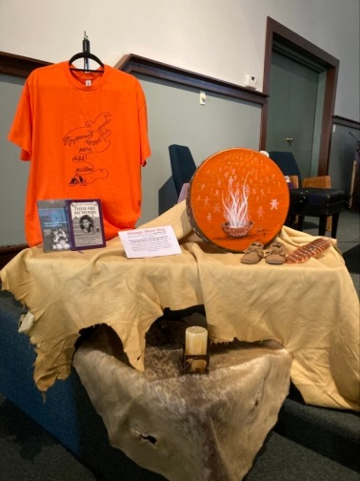
Living Into Right Relations

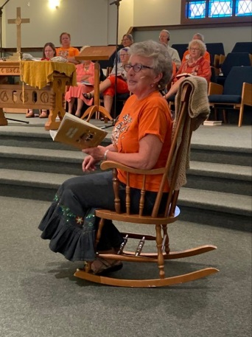

September 25, orange shirt day was celebrated at St. Andrew’s. Cecile Fausak read the children’s book story “When we were alone”. Don with his Metis family from Georgian Bay, Ontario and Winnie drummed and sang. The church was filled with orange shirts.

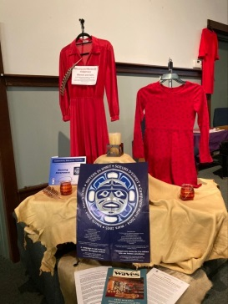
October 4, a Red Dress vigil for the Missing and Murdered women and girls was held at the Church’s court yard. Many attended. A talking circle and tea took place afterwards in the sanctuary.

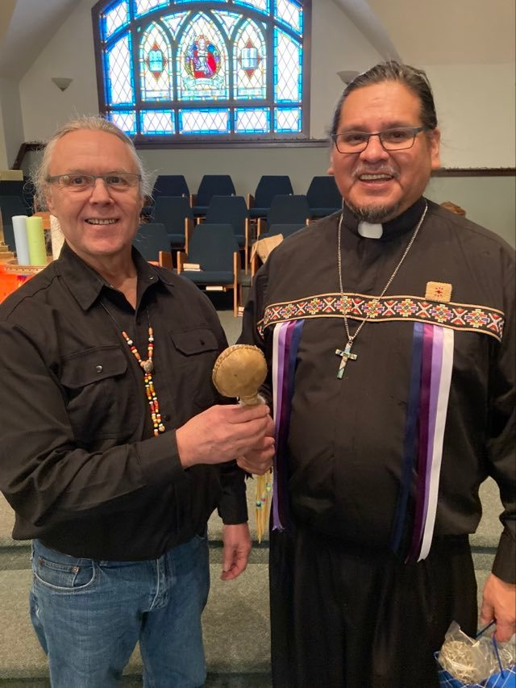

December 18, Rev. Tony Snow, Indigenous minister for Chinook Winds Region and a member of the Stoney Nakoda First Nation was welcomed to our congregation. Rev. Tony spoken message was on reconciliation. Don Fraser presented Tony with a hand crafted rattle. He enjoyed coffee with the congregation and a meal, with the LiRR group.

2022 our Living into Right Relations group has expanded and members now include, Rev Dave Holmes, Bob and Winnie Settle, Cecile Fausak, Bruce Jackson, Terry Souveny, John VerDerMeulen, Tom Crozier, Doug Maas, Don Fraser and Tilly Meyer.

Summited by Tilly Meyer

PROPERTY

It has been a pretty easy year when it comes down to property related projects. Nothing big got tackled this year. No major expenses either that were unforeseen.
The overhang above the outside door of the hall got fixed up, it was leaking and caused one of the two chains that hold it even to come out of the roof.
The church still needs a few shingles, hopefully next summer there is a contractor that can do the job.
I would like to thank everyone for their help once again, I appreciate it very much.
Jurjan Dunnewind, Chair

UCW 1

“Friends are the fruitcake of our lives. Some are nutty, some are soaked in alcohol, some firm, some sweet but altogether, they are great to have in your life” Each of us are a different, important ingredient to the mixture and we come together to make a wonderful fruitcake. Our unit is called the fruitcakes and we wear that title with warmth, humour and love.
We have approximately 22 members. We meet twice a year in February and September for formal meetings but get together often for Fun, Fellowship and Service. This year we made 8 batches of fruitcakes (including 1 gluten free) which made approximately 80 large cakes and 30 smaller cakes. At present the division of the money has not been decided. Decisions will be made at our February meeting.
Our members have been meeting Thursday mornings for coffee at Kavacchinos for about 22 years. Sadly Kavacchinos closed in September 2022. We now meet at Anna Maries at 9:30 Thursday mornings. We meet for fellowship, friendship and sharing. Sharing our Joys and Sorrows. This year we mourn the loss of a dear member Madeline Hendrickson and member Peggy DeForge’s husband Tom. Money was collected in memory of Nana Madeline and a memorial donation will be made to Camp Kasota, a place dear to Madeline’s heart.
This year we gathered for Saturday lunches, dinner and movie night, wing night, kayaking at Gull Lake, and Christmas dinner with games. We helped with the church garage sale fundraiser, along with UCW unit 2 we hosted a congregational Christmas tea. A few members got together for pizza and made Gnome center pieces for the tea which were later sold.
On the third Sunday of each month, we serve coffee and treats for fellowship after the church service, and we also provide birthday cake for anyone celebrating a birthday that month. Our unit provides fair trade coffee for the church to use.
We are looking forward to 2023. Praying for renewed friendships, continued fellowship and more Fruitcake!

UCW 2

Unit 2 currently has 17 members. Generally, we meet once a month, the 3rd Tuesday, at 2:00 p.m. We meet mid-afternoon because ‘we can’ and it means none of our members are travelling on dark, stormy evenings. Most of our meetings are held in the church parlor. Although they are ‘business meetings’, there is always time for visiting and socializing. Twice a year (or more) we lunch out, Spring and Christmas.

In the past year, we have catered two funeral lunches and one 90th birthday celebration. As well, our members are involved with many other Church activities such as Coffee Sunday (the 1st Sunday of every month), cooking for our Messy Church group, helping with the Garage Sale and ‘Lift Someone into the Light’, one of the Advent activities. In conjunction with Unit 1, we hosted our annual Christmas Tea for the congregation. As well, several of our members deliver ‘Meals on Wheels’ for FCSS during the month of August.

Our donations this year include the Lacombe Food Bank, Canadian Food Grains Project, FCSS Fill a fridge, Santa’s Anonymous and Camp Kasota.
Respectfully submitted,
Susan Hrycan
Unit 2

UCW PURPOSE: To unite all women of the congregation for the total mission of the Church and to provide a medium through which they may express their loyalty and devotion to Jesus Christ in Christian witness, study, fellowship, and service.

WORSHIP TEAM

“And suddenly you know: It’s time to start something new and trust the magic of beginnings.” Meister Eckhart.
That is how Pat and Shelley-May felt in May. We had been on the Worship team for over 17 years and we now have a wonderful minister Dave and a fantastic person in the office. It was time for both of us to move on and have new people join the Worship team and for the team to go in a new direction. We have to trust in the magic of beginnings and in God.
Our year was very busy with the church being fully open again and attempting new things in the church services and undertaking a few projects. One new endeavour was trying new ways of getting people involved in the services like being a scripture readers or story tellers or having families participate in the communion. To enhance and add variety to the services, Dave implemented many different themes, activities within the services, added different parts to the services and his sermons were thought provoking and enlightening. AFFIRM, FROGS, LIRR, Rev. Bob Settle, Dieulita Datus, Rev. Ross Smillie and Rev. Barbara Lieurance led some of our services which not only added some diversity but were a blessing. There were Lent and Advent teams set up to not only bring new ideas into the fold but to continue past activities and to implement them too. Worship had meetings with the communications team, CD and a music meeting in which there was discussion about new things that could happen with the Worship team and with Sunday Worship. We had a very full year.
Worship received special presents, one in June with Barbara having more hours added to her job at St. Andrew’s, and in November the donation of a beautiful Christmas tree. Other gifts that should be mentioned are the amazing displays that AFFIRM, Don and Tilly, and Howard and Marg Woodrow shared with us.
There are so many people over the years that we worked with and so many wonderful generous people who participated in Worship services or helped us perform our duties in one form or another. This last year, Lawrence Hrycan took the lead with AV whether it was getting the equipment set up or running the live streaming and AV equipment most Sundays. Our AV personnel of Tristan, Brendan and Brielle have been phenomenal. We are very grateful for our amazing choir director Leanne and our very talented pianist Nicole. We would like to thank Carol Cornwell for arranging our gathering music and for helping us when we need a pianist along with Darryl Langille. To all the people who shared your talents of music leading hymns over the last couple of years, or were greeters or scripture readers, thank you so much. Sarina was our excellent usher/greeter coordinator. Last of all, we are so thankful for the wonderful lady in our office, Jana, who has helped us out immensely. All of you have made our time memorable.
Pat and Shelley-May

WORSHIP TEAM

Audio Visual Technology at St. Andrew’s

St. Andrew’s is very fortunate to have the media presence both in the sanctuary and on-line through YouTube. This is, in part, because of the decisions that the board has made to keep technology alive and well.
The equipment over the last 18 months has been updated. There are now 2 cameras to record and show events in the sanctuary. The overhead projectors in both the sanctuary and the auditorium have been replaced. With the new technology, whatever is being shown in the sanctuary can be shown in the auditorium. Moms and dads who use the nursery no longer need to depend on the speaker in the nursery. They can now use their cell phones to follow the service. Microphones have been updated so that ministers and others are not confined to the pulpit. And the sound is good.
Every Sunday morning a PowerPoint is presented to supplement the service. Congregational members have been making positive comments on this. Three teens ensure that the Sunday morning services are live-streamed. We average 70 people every Sunday morning sitting in the pews, as well as another 25 or so on-line. We attract many more “views” throughout the day following the service. If you have not had an opportunity to view Reverend Dave on-line, take some time to do so. In addition, weddings and funerals at St. Andrew’s have also been viewed on YouTube. Many of our church services have had 200 to 400 views and one of the weddings that Reverend Barbara performed has had over 460 people view it. YouTube likes what we are doing so much so that there are often commercials at the beginning of each video. Having commercials attached to your video means you have had a great number of people viewing. The more, the better!
Our live streaming on YouTube has brought in donations from all over the province. The comments in the chat room and in emails from individuals tell us how much they appreciate our media presence. The comments are very much appreciated.
Submitted by,
Lawrence Hrycan
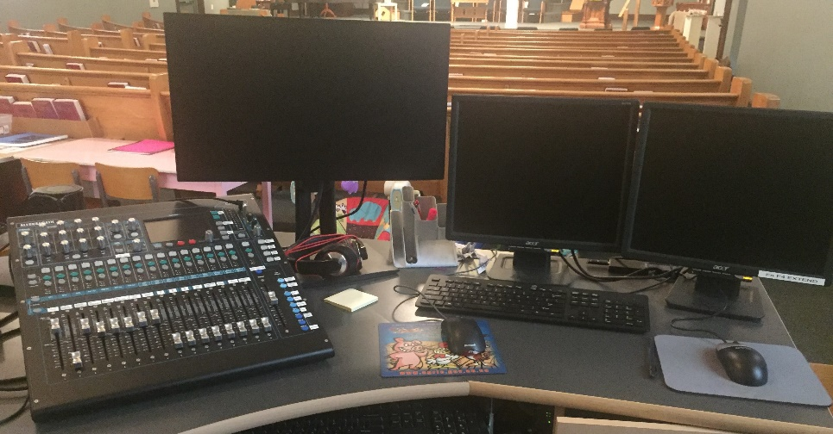

CHURCH STATISTICS FOR 2022

Marriages 2022 (4)
Eric Holmes / Vanessa Hamel
Dillon Richman / Stephanie O’Neill
Chelsie Hunt / Heidi Sturge
Brady Young / Vanessa Schmidt

Funerals 2022 (17)

Cecil Woods
Verna Schmidt
Pearl Macleod
Jessie Orr
Marguerite Simpson
Robert Brooks
Howard Fredeen
Joseph Willis
Madeline Hendrickson
Gary Nymoen
Jessie Nymoen
Harry Nymoen
Earlene Sahlin
Madge Hull
Donald Pickett
Marion Hahn
Myrtle Carson

Baptisms 2022 (1)
Kevin Dunnewind

Confirmations 2022 (0)

Transfers 2022 (1)
Graham & Michelle Russell

